3.11 Case Example

Read example given in the book for this section.

Example: HS and College GPA (GPA_3.11_example.R)

The following will be examined relative to the HS and College GPA data set:

- Diagnostics for predictor and response variable
- Linearity of the regression model
- Constant error variance
- Independence of ε_{i}
- Outliers
- Normality of ε_{i}
- Additional predictor variables

To help you out, I have written a function that automates many of the plots done before. While this function will make your life a little easier, you are still responsible for understanding all parts of it. Also, this function serves as a great example of how you can easily program your own function to do items in this class.

The function called examine.mod.simple() is in the program examine.mod.simple.R. Run this program once before running the corresponding function for any data set. This needs to be done for each R session. I recommend actually using the examine.mod.simple.R program instead of copying and pasting the code shown next into your own program!

Code:

#########################################################
# NAME: Chris Bilder # DATE:
# UPDATE:
# Purpose: Automate part of the simple linear regression
diagnostic procedures into one function.
# NOTES: This function needs to be run just once before it
used. One needs to call the function with the
model fit object only. For example,

# examine.mod.simple(mod.fit.obj = mod.fit) #
# The seed for jittering can be changed with the
seed option. Also, the Levene and Breusch-
Pagan test can be performed if the const.var.test
option is change to TRUE. Note that the
car and lmtest packages need to be loaded for
these tests. The X and Y optional values can be
used if a transformation of X or Y was used for
the model. For example, if log(Y) was used, then
fit the model with log(Y) and include the Y =
log(original Y variable) when invoking this
function. The boxcox.find = TRUE option produces
an estimate for lambda. ###########################################################

examine.mod.simple<-function(mod.fit.obj, seed = 9180,
const.var.test = FALSE, X = NULL, Y = NULL,
boxcox.find = FALSE) {

n<-length(mod.fit.obj$residuals)

if (is.null(X)) { X<-mod.fit.obj$model[,2]}
if (is.null(Y)) { Y<-mod.fit.obj$model[,1]}

##########################################################
#Graph window #1

#Open a new plotting window 2x2
win.graph(width = 6, height = 6, pointsize = 10)
par(mfrow = c(2,2))

set.seed(seed)
boxplot(x = X, col = "lightblue", main = "Box plot",
ylab = "Predictor variable", xlab = " ") #(1,1)
stripchart(x = X, method = "jitter", vertical = TRUE,
pch = 1, main = "Dot plot", ylab = "Predictor
variable") #(1,2)
boxplot(x = Y, col = "lightblue", main = "Box plot",
ylab = "Response variable", xlab = " ") #(2,1)
stripchart(x = Y, method = "jitter", vertical = TRUE,
pch = 1, main = "Dot plot", ylab = "Response
variable") #(2,2)

#Initial summary statistics
summary.data<-summary(data.frame(Y,X))
##########################################################
#Graph window #2

#Open a new plotting window 2x2
win.graph(width = 6, height = 6, pointsize = 10)
par(mfrow = c(2,2))

sum.fit<-summary(mod.fit.obj)
semi.stud.resid<- mod.fit.obj$residuals/sum.fit$sigma

#(1,1) - Scatter plot with sample model
plot(x = X, y = Y, main = "Response vs. predictor",
xlab = "Predictor variable", ylab = "Response
variable", panel.first = grid(col = "gray", lty =
"dotted"))
curve(expr = mod.fit.obj$coefficients[1] +
mod.fit.obj$coefficients[2]*x, col =
"red", add = TRUE, xlim = c(min(X), max(X)))

#(1,2) - e.i vs. X.i
plot(x = X, y = mod.fit.obj$residuals, ylab =
"Residuals", main = "Residuals vs. predictor",
xlab = "Predictor variable", panel.first =
grid(col = "gray", lty = "dotted"))
abline(h = 0, col = "red")

#(2,1) - e.i vs. Y.hat.i
plot(x = mod.fit.obj$fitted.values, y =
mod.fit.obj$residuals, xlab = "Estimated mean
response", ylab = "Residuals", main = "Residuals
vs. estimated mean response", panel.first =
grid(col = "gray", lty = "dotted"))
abline(h = 0, col = "red")

#(2,2) - e.i.star vs. Y.hat.i
plot(x = mod.fit.obj$fitted.values, y =
semi.stud.resid, xlab = "Estimated mean response",
ylab = "Semistud. residuals", main =
expression(paste(e[i]^{"*"}, " vs. estimated mean
response")), panel.first = grid(col = "gray", lty
= "dotted"), ylim = c(min(semi.stud.resid,-3),
max(semi.stud.resid,3)))
abline(h = 0, col = "red")
abline(h = c(-3,3), col = "red", lwd = 2)
identify(x = mod.fit.obj$fitted.values, y =
semi.stud.resid)

#########################################################
#Graph window #3

#Open a new plotting window 2x2
win.graph(width = 6, height = 6, pointsize = 10)
par(mfrow = c(2,2))

#e.i vs. obs. number
plot(x = 1:n,, y = mod.fit.obj$residuals, xlab =
"Observation number", ylab = "Residuals", type =
"o", main = "Residuals vs. observation number",
panel.first = grid(col = "gray", lty = "dotted"))
abline(h = 0, col = "red")

#Histogram of the semi-studentized residuals with
normal distribution overlay
hist(x = semi.stud.resid, main = "Histogram of semi-
stud. residuals", xlab = "Semi-stud. residuals",
freq = FALSE)
curve(expr = dnorm(x, mean = mean(semi.stud.resid), sd
= sd(semi.stud.resid)), col = "red", add = TRUE)

#QQ-plot done by R
qqnorm(y = semi.stud.resid, ylab = "Semi-stud.
residuals", panel.first = grid(col = "gray", lty
= "dotted"))
qqline(y = semi.stud.resid, col = "red")

#Save all results so far
save.res<-list(sum.data = summary.data, semi.stud.resid =
round(semi.stud.resid,2))
##########################################################
#Levene and BP tests - Examine the residuals for
normality

if (const.var.test) {

library(car) #The Levene's Test function is in the
package for Fox's book
group<-ifelse(test = X < median(X), yes = 1, no = 2)
save.levene<-leveneTest(y = mod.fit$residuals, group =
factor(group))

library(lmtest) #Location of BP test function
save.bp<-bptest(formula = Y ~ X, studentize = FALSE)
#KNN Version of the test

save.res$levene<-save.levene
save.res$bp<-save.bp

}

##########################################################
#Box-cox transformation

if (boxcox.find) {

library(MASS) #Function is in the MASS library
save.bc<-boxcox(object = mod.fit.obj, lambda = seq(from
= -2, to = 2, by = 0.01))
title(main = "Box-Cox transformation plot")
lambda.hat<-save.bc$x[save.bc$y == max(save.bc$y)]

save.res$lambda.hat<-lambda.hat

}

#########################################################
#Return results

save.res

}

Notes:
- The function just puts together much of the same code that we have seen before for this chapter!
- The identify() function allows one to interactively identify points on a plot. I used this function with the 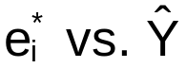 plot to help identify outliers. When this plot appears, simply left click the mouse next to the point that you want to identify. R will put the observation number next to the point. When you are done identifying observations, right click the mouse and select STOP.
- I stored the summary information for each variable and the semi-studentized residuals in a list object. These items can be accessed then just like those from when the lm() function is used.
- The e_{i} vs. observation number plot has not been shown before. For the x-axis, I simply used x = 1:n to plot the residuals against. The type = “o” option joins the points with a line.
- The Levene and Breusch-Pagan tests are optional. By default, they will not be run. If you want to run them, use the var.test = TRUE option in the call to examine.mod.simple(). Notice in the program how I use an if() function to implement these tests.
- A good way to learn what every part of the function code does is to not run the function directly, but instead step through it. For example, set mod.fit.obj<- ___ for your data of interest and then begin running each line of the function one at a time.

Below is the code and output for the HS and College GPA data set:

> mod.fit<-lm(formula = College.GPA ~ HS.GPA, data = gpa)
> save.it<-examine.mod.simple(mod.fit.obj = mod.fit,
const.var.test = TRUE)
> save.it
$sum.data
Y X
Min. :1.400 Min. :0.830
1st Qu.:1.975 1st Qu.:2.007
Median :2.400 Median :2.370
Mean :2.505 Mean :2.569
3rd Qu.:3.025 3rd Qu.:3.127
Max. :3.800 Max. :4.320

$semi.stud.resid
1 2 3 4 5 6 7 8 9 10 11 12 13
0.89 -0.17 1.36 -0.81 -0.63 -0.10 1.08 0.91 0.71 1.05 -1.28 -1.22 1.00
14 15 16 17 18 19 20
-0.63 0.80 -1.16 -1.02 0.99 -0.35 -1.42

$levene
Levene's Test for Homogeneity of Variance
Df F value Pr(>F)
group 1 0.0766 0.7851
18

$bp
Breusch-Pagan test
data: Y ~ X
BP = 0.1959, df = 1, p-value = 0.658

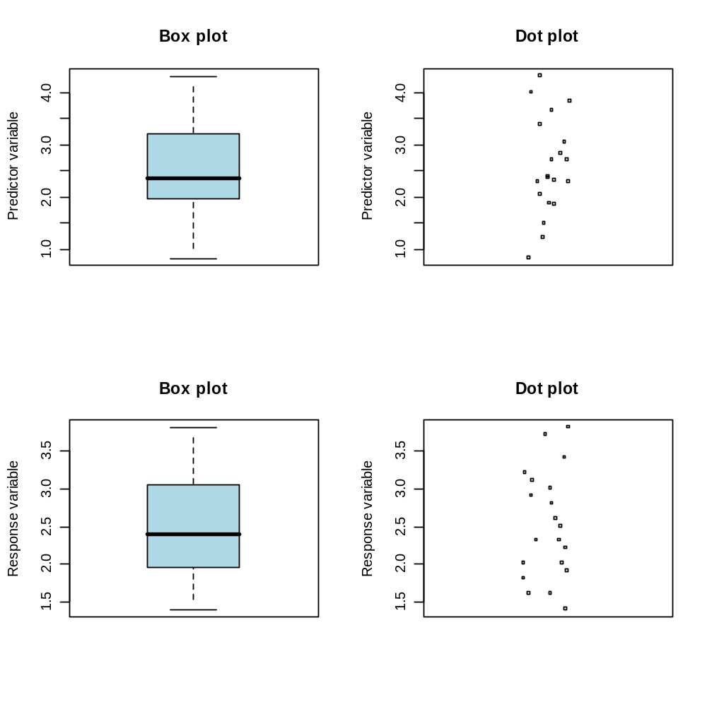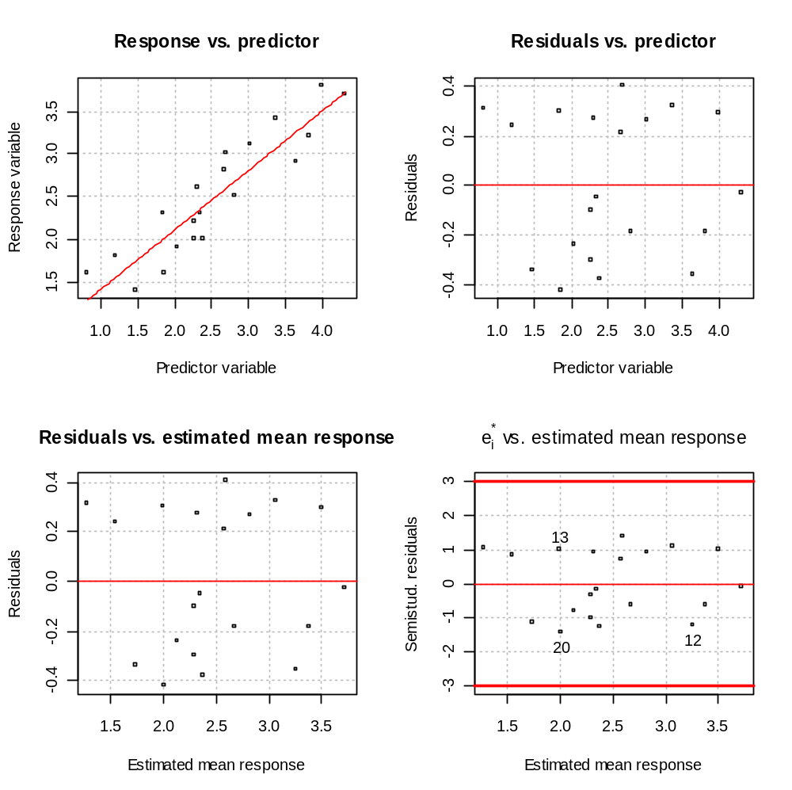
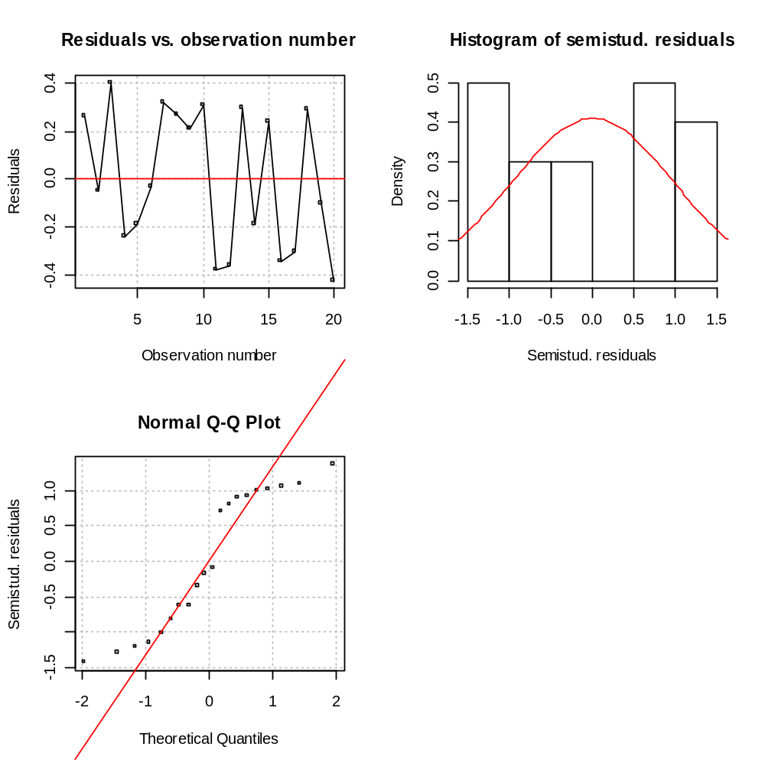

- Diagnostics for predictor and response variable

There are no outlying values and the range of the X values are 0.83 to 4.32.

- Linearity of the regression model

Examine the plot of e_{i} vs. X_{i}. The points appear to be randomly scattered in the plot. Therefore, there does not appear to be a transformation needed.

- Constant error variance

Examine the plot of e_{i} vs. . The points appear to be randomly scattered in the plot. The constant variance tests had large p-values. Therefore, there does not appear to be a transformation needed.

- Independence of ε_{i}

Examine a plot of e_{i} vs. order of the observation. The points appear to be randomly scattered in the plot. Therefore, the ε_{i} do not appear to be dependent.

- Outliers

Examine a plot of  vs. with reference lines at =–3 and =3. There are no >3 or <-3. Therefore, there does not appear to be any outliers. I did identify a few observations ONLY to demonstrate how it could be done. Normally, you would want to identify only those outside of the -3 to 3 range .

- Normality of ε_{i}
Examine the histogram and QQ-plot of . Both plots show that there could be a problem with normality. This is because the points on the QQ-plot tend to deviate from the straight line and the shape of the histogram is poorly approximated by the normal distribution curve. Normality though is hard to assess with only a sample of size 20. Transformations of the dependent variable will be considered to see if we can find an improvement over the current results.

- Additional predictor variables

I will do this after seeing if we can find a fix for the potential normality problem.

Investigate transformation of Y:

Although regression analysis is robust to nonnormality, some transformations are investigated.

> mod.fit2<-lm(formula = log(College.GPA) ~ HS.GPA, data
= gpa)
> save.it2<-examine.mod.simple(mod.fit.obj = mod.fit2,
const.var.test = TRUE, Y =
log(gpa$College.GPA))
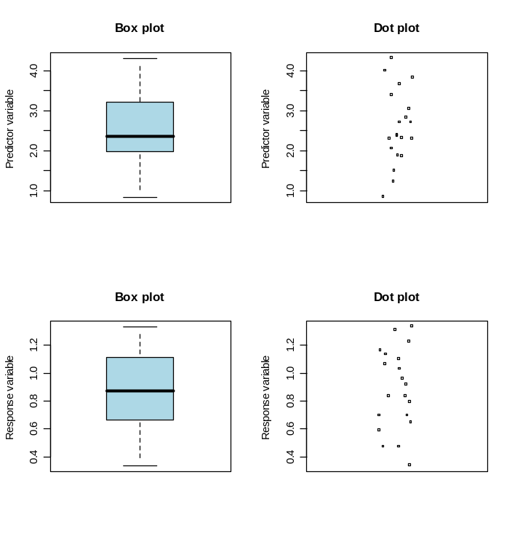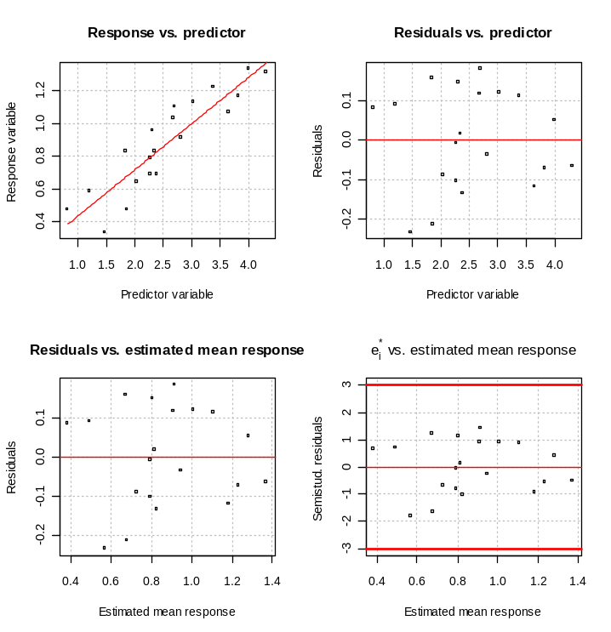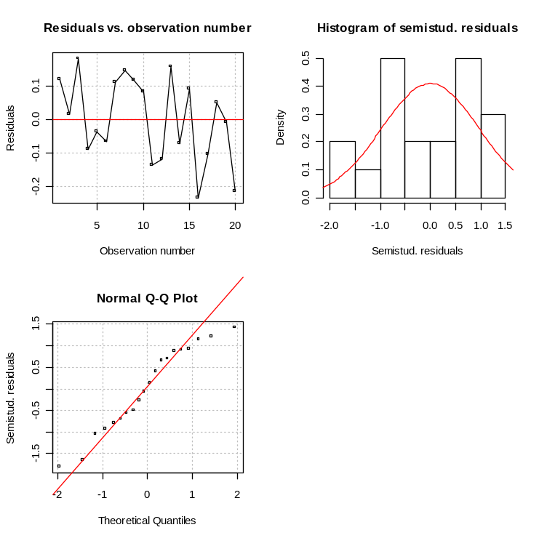

> mod.fit3<-lm(formula = sqrt(College.GPA) ~ HS.GPA, data
= gpa)
> save.it3<-examine.mod.simple(mod.fit.obj = mod.fit3,
const.var.test = TRUE, Y =
sqrt(gpa$College.GPA))
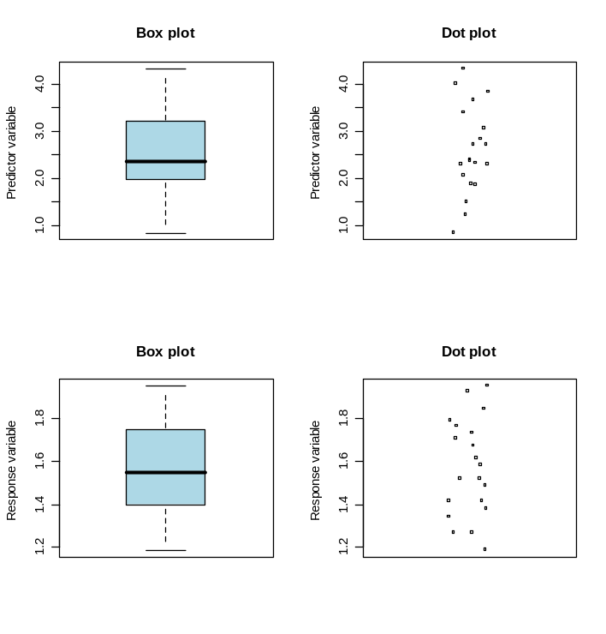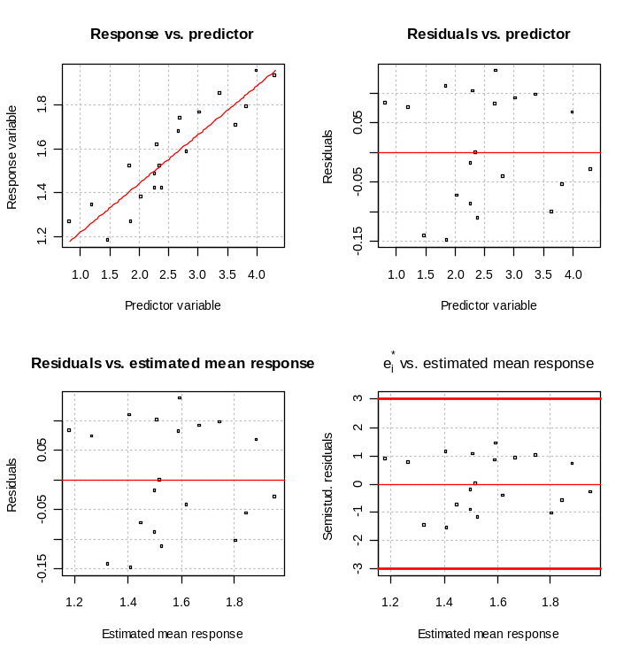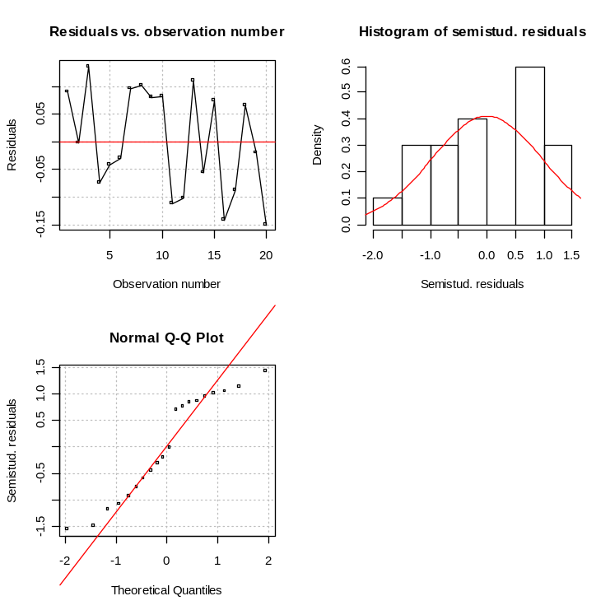

> mod.fit4<-lm(formula = 1/College.GPA ~ HS.GPA, data =
gpa)
> save.it4<-examine.mod.simple(mod.fit.obj = mod.fit4,
const.var.test = TRUE, Y = 1/gpa$College.GPA)
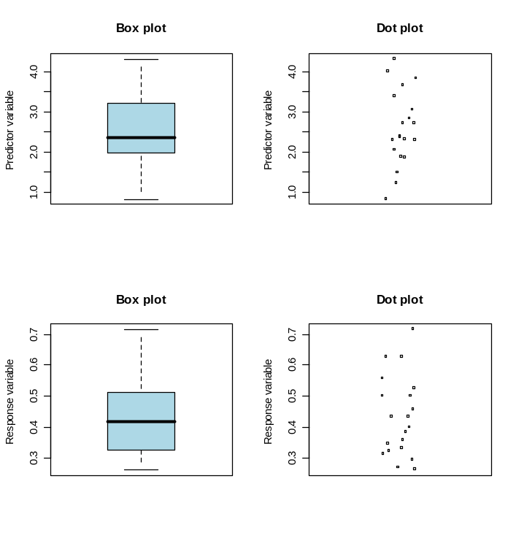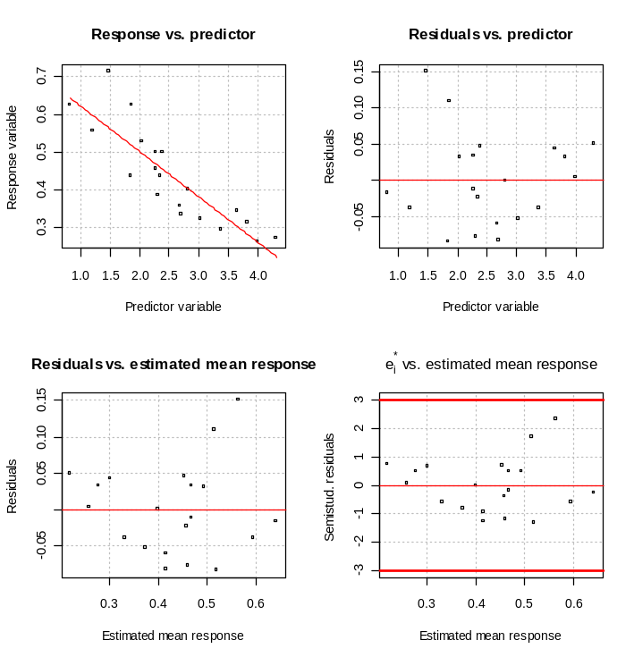
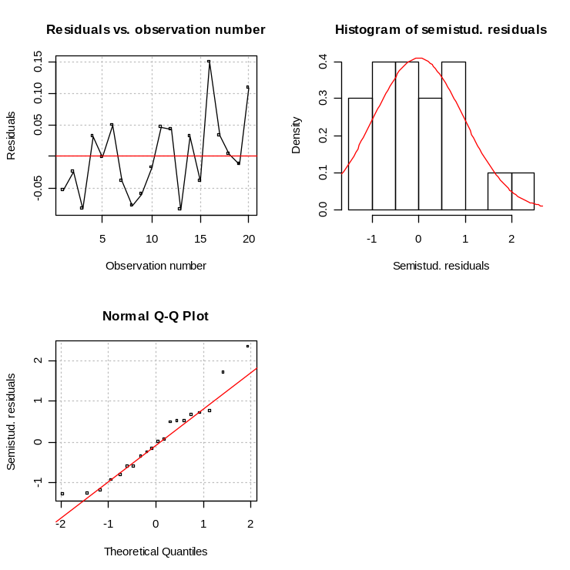

Comments:
- There are not any new problems that appear when using a transformed Y.
- The QQ-plots using log(Y) look to be the best. While there are still some departures from normality, it looks like the log transformation did improve it some.
- The histograms still do not look like a normal distribution.
- Again with a sample size of only 20, it is difficult to assess the normality assumption of the regression model.
- If I did use a transformation, I would use the log transformation. Given the robustness against normality problems and the difficulty with assessing normality with a sample of size 20, the log transformation or no transformations would be acceptable.
- If the log transformation model were used, the model would be expressed as:  where Y = College GPA and X = HS GPA. Below is the summary() output for the model.

> summary(mod.fit2)

Call:
lm(formula = log(College.GPA) ~ HS.GPA, data = gpa)

Residuals:
Min 1Q Median 3Q Max
-0.234085 -0.093411 0.003890 0.113817 0.182895

Coefficients:
Estimate Std. Error t value Pr(>|t|)
(Intercept) 0.15184 0.08690 1.747 0.0976 .
HS.GPA 0.28292 0.03189 8.871 5.46e-08 ***
---
Signif. codes: 0 '***' 0.001 '**' 0.01 '*' 0.05 '.' 0.1 ' ' 1

Residual standard error: 0.1294 on 18 degrees of freedom
Multiple R-Squared: 0.8138, Adjusted R-squared: 0.8035
F-statistic: 78.69 on 1 and 18 DF, p-value: 5.462e-08

- Additional predictor variables

Would the model work better if an additional variable, pizza consumption, were added to the model? If so, the model would be a “multiple” regression model of the form
E(Y) = β₀ + β₁X₁ + β₂X₂

where Y = College GPA, X₁ = HS GPA, and X₂ = Pizza consumption. I am only going to consider the model without any transformations.

In general, we can examine a plot of e_{i} vs. the new variable to assess whether or not a new variable should be added to the model. If there is a pattern, the variable should included. If there is not a pattern, the variable should be not included. Why?

These plots can be obtained with the following code:

> gpa2<-read.table(file =
"C:\\chris\\UNL\\STAT870\\Chapter2\\data\\College_GPA_pizza.txt", header=TRUE, sep = "")
> head(gpa2)
pizza College.GPA
1 2 3.1
2 9 2.3
3 3 3.0
4 5 1.9
5 3 2.5
6 1 3.7

> par(mfrow = c(1,1))
> plot(x = gpa2$pizza, y = mod.fit$residuals, xlab =
"Times ate pizza", ylab = "Residual", main =
"Residual vs. Pizza consumption", panel.first =
grid(col = "gray", lty = "dotted"))
> abline(h = 0, col = "red")
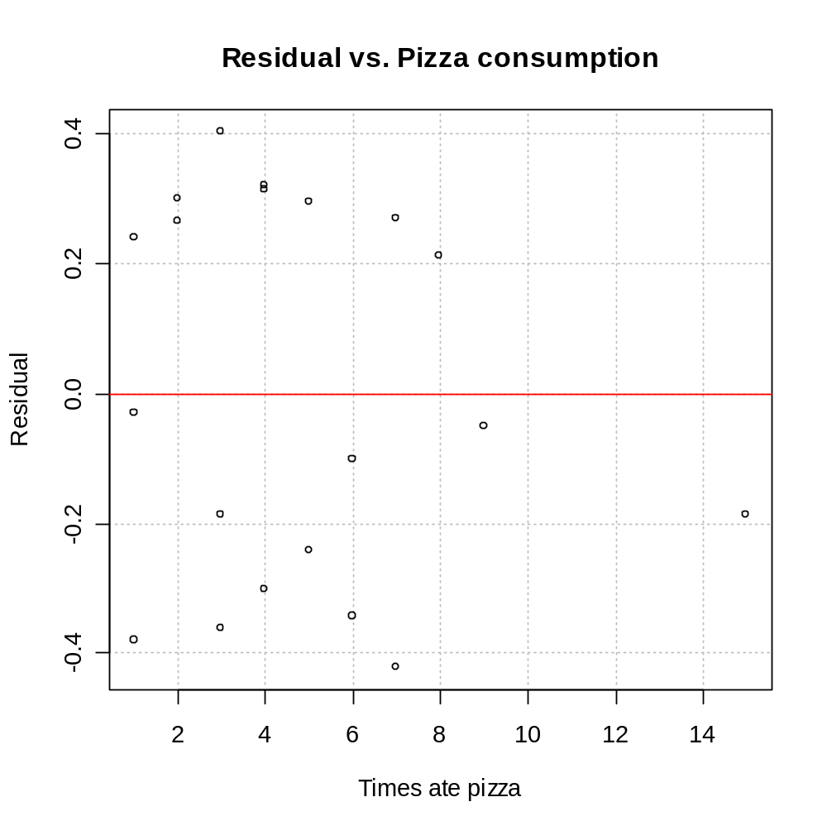
The points appear to be randomly scattered in the plot. Therefore, pizza consumption does not appear to be a useful additional variable.

See p. 113 for another example of what these types of plots may look like. If we plotted residual vs. X₂ = 0 for company A and X₂ = 1 for company B, our plot would look like

Again, a pattern can be seen so X₂ should be included in the model. X₂ is called an indicator variable, which is used to include qualitative predictor variables (like, company) in a regression model. We will discuss qualitative predictor variables in more detail later.

3.10 Exploration of shape of regression function

Read on your own.

